Complete, mail, or email this form to the following address to ensure inclusion in some print materials:

The Sandy Springs Conservancy Inc.
227 Sandy Springs Place
Suite D 470
Sandy Springs, GA 30328

director@sandyspringsconservancy.org

Please select level of sponsorship:
Diamond: _____ $10,000 Platinum: _____ $5,000 Gold: _____ $2,500 Silver: _____ $1,000

Company Name (How you would like to be recognized?)
_______________________________________________________________________________________
Contact ________________________________________________________________________________
Address________________________________________________________________________________
City _________________________________ State ____________________________ Zip _____________
Phone ________________________ Email ___________________________________________________
Website _______________________________________________________________________________

Please email your logo in JPEG or JPG format to director@sandyspringsconservancy.org
Sponsors will be invoiced for sponsorship amount.

Thank you for your support of the Sandy Springs Conservancy. We deeply appreciate your contribution to our organization and to a more vibrant, walkable, and bikeable Sandy Springs. Call us if you have any questions at 678-642-0680. We look forward to seeing you at our annual Thought Leaders Dinner and at our parks and trails.

Sincerely,
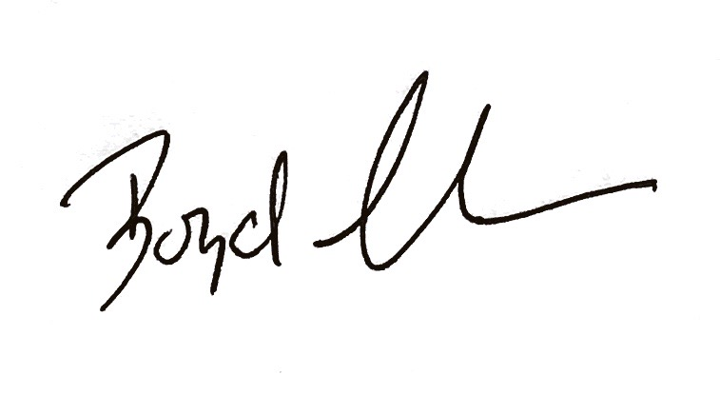
Jack Misura G. Boyd Leake
Chair of Sandy Springs Conservancy Executive Director

